NGO FIELD VISIT LOG SYSTEM
@CREATIVITY THINK (9483175986/7019689991)

ABSTRACT:
NGO Field Visit Log System is a web-based application designed to streamline the documentation of field activities conducted by NGO teams, CSR units, and social service clubs. The platform enables field staff to view assigned visit plans, log daily activities, record beneficiary details, upload photo proofs, and track their contribution impact. Administrators can assign structured visit templates, verify submitted logs, manage approvals, and view consolidated analytics on outreach, locations, and impact metrics. Built using Django REST Framework for backend APIs and React for an interactive frontend dashboard, the system provides transparency, accountability, and data-driven insights for social impact reporting..

INTRODUCTION OF THE PROJECT:
NGOs and community service organizations often conduct frequent field visits involving workshops, surveys, distribution programs, and beneficiary interactions. Traditional reporting methods using paper logs, WhatsApp messages, or spreadsheets create inconsistencies, delays, and a lack of uniform documentation.
The NGO Field Visit Log System provides a centralized digital solution that standardizes reporting, ensures evidence-based logging, and simplifies monitoring for administrators. It allows field teams to document visits as they happen while providing management with reliable analytics and verifiable impact records..

PROJECT OBJECTIVES:

• Provide field staff with structured visit plans assigned by admins
• Enable logging of activities such as workshops, surveys, and distribution events
• Record beneficiary counts, demographic data, and supporting photos
• Allow staff to submit daily visit logs for approval
• Provide personal dashboards for staff to track their own contribution impact
• Allow admins to design custom visit templates and assign tasks
• Enable review, verification, approval/rejection of submitted visit logs
• Provide consolidated reports for CSR documentation and donor submissions
• Generate charts and analytics on outreach, locations, and beneficiary metrics

PROBLEM OF THE STATEMENT:
NGOs often struggle with scattered and inconsistent field visit documentation, making it difficult to track real-time progress, verify activities, or prepare formal impact reports. Photo evidence and beneficiary data collected across different sources can lead to duplication or data loss.
The proposed system solves these issues by providing a unified digital platform for structured logging, evidence-based verification, and analytics-driven reporting for all field visits conducted by NGO teams..

MOTIVATION OF THE PROJECT:
• To digitize the manual field reporting workflow used by NGOs
• To promote accountability and transparency with verifiable evidence
• To reduce paperwork and communication delays
• To create standardized templates for different types of field activities
• To provide real-time monitoring to administrators and CSR teams
• To generate reliable and professional analytics for donor reporting
• To help NGOs scale their operations by improving documentation quality

BLOCK DAIGRAM OF PROJECT:

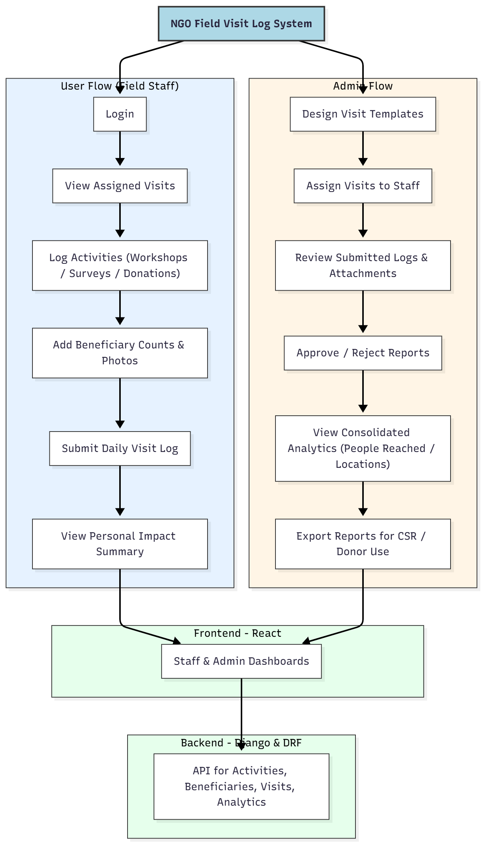

WORKING OF THE PROJECT:
Field staff log into the system and access their assigned visits created by the admin. Each visit contains predefined templates for the activities they must complete. During the visit, staff log details such as activities executed, number of beneficiaries reached, and attach photo proof as verification. Upon completion, a daily log is submitted for admin approval.
Admins review the submission, verify photos, check activity accuracy, and approve or reject the report. Approved logs contribute to consolidated analytics used to generate CSR reports, donor presentations, and internal performance metrics. Staff can view their personal impact statistics such as total beneficiaries reached or total completed visits..

SOFTWARE REQUIREMENT:
- Backend:
  - Python 3.x
  - Django
  - Django REST Framework
  - SQLite/PostgreSQL
- Frontend:
  - Node.js and npm
  - React.js
  - Axios
- Development Tools:
  - Visual Studio Code
  - Postman (for testing APIs)
  - Git/GitHub (for version control)
- Server/Deployment (Optional):
  - Gunicorn, Nginx, or Heroku/AWS for hosting

ADVANTAGES OF THE PROJECT:

• Structured, standardized field visit documentation
• Verifiable photo-based evidence
• Improved accountability and transparency
• Real-time dashboards for tracking impact metrics
• Easy export of CSR and donor reports
• Reduces manual paperwork and communication errors
• Enhances staff efficiency and clarity of assigned tasks

APPLICATIONS OF THE PROJECT:
• NGO field operations
• CSR project implementation
• Social service clubs
• Charity organizations
• Community outreach teams
• Educational outreach programs
• Rural development fieldwork

REFERENCES:

- Django REST Framework Documentation — Django Software Foundation. Django Documentation. Available: https://docs.djangoproject.com/
- Django REST Framework. DRF Documentation. Available: https://www.django-rest-framework.org/
- React. React Official Documentation. Available: https://reactjs.org/docs/getting-started.html
- Redux. Redux Documentation. Available: https://redux.js.org/introduction/getting-started
- PostgreSQL Global Development Group. PostgreSQL Documentation. Available: https://www.postgresql.org/docs/
- MySQL. MySQL Reference Manual. Available: https://dev.mysql.com/doc/
- Git. Git Documentation. Available: https://git-scm.com/doc
- Node.js. Node.js Documentation. Available: https://nodejs.org/en/docs/
- Axios. Axios Documentation. Available: https://axios-http.com/docs/intro
- Socket.io Documentation – https://socket.io/docs/

